3D Vision – Exercise 2

Yuval Shaffir

208448068

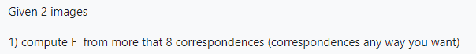

F is a rank 2 3x3 homogeneous matrix with 7 degrees of freedom.

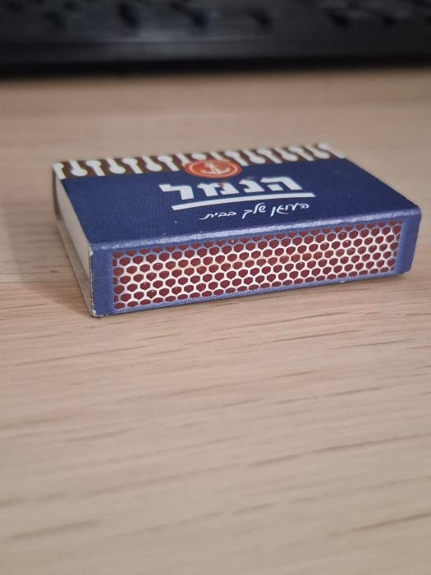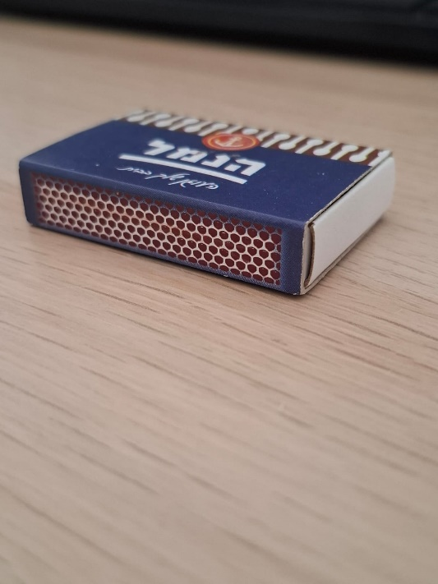I have taken two pictures of a matchbox from two different camera positions and loaded them into our script:

First, I initialized a **SIFT (Scale-Invariant Feature Transform)** detector to identify keypoints and compute their descriptors for both images and then visualized it:

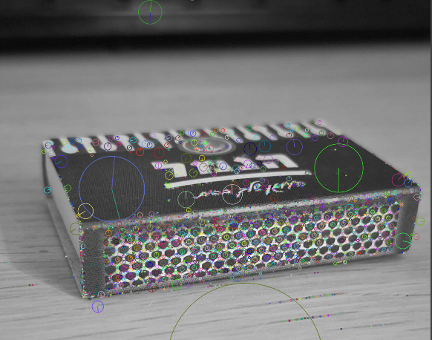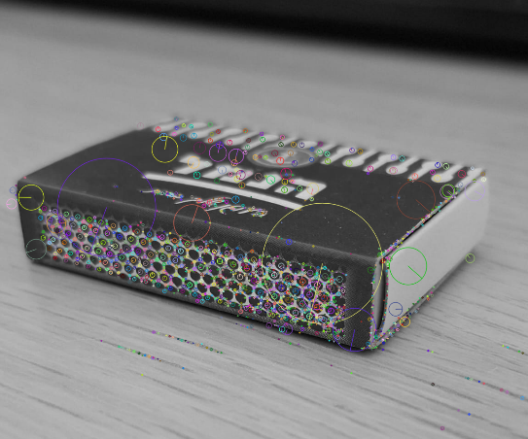

Then we match the points of both images using a BFS matcher algorithm on the descriptors. we will get an array of points from which we can find the **Fundamental Matrix**  robustly estimating it with the RANSAC method:



Epipole points represent the point of intersection of the line joining the camera centers (the baseline) with the image plane.

I've computed the epipole points that satisfy the following multiplication: .

We can do that by calculating the null space vector using SVD: where the last column of gives the right null space vector, and similarly, the last column of gives the left null space vector.

We get that:



To compute the epipolar lines, we use the equation where F is the fundamental matrix and is a match point. We do that for every match point we have found, and we get the following results, where the little red star is the epipole point, and the lines represent the epipole lines of each image:

The right image with :

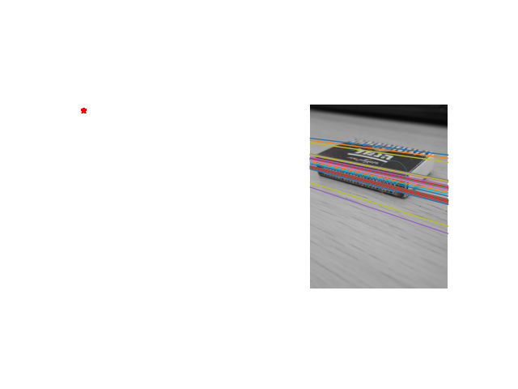

The left image with :

